PRESS RELEASE | 3 September 2012

Who Invented Space Dinosaurs?

MJ Hibbett spent 20 years turning his story of dinosaurs returning from space into a musical and album, so was amazed to discover that the same story would also be the basis for the next episode of Doctor Who.

He first had the idea for 'Dinosaur Planet' in the early 90s, but it took him until 2009 to turn it into a live musical. "It's all about the real reason the dinosaurs disappeared," he says, "how they managed to get home from space after 65 million years, and why they're being pursued by giant robots."

Anyone who watched the end of Doctor Who on Saturday (1 September) might find this strangely familiar, as that's exactly what's promised in next week's episode, 'Dinosaurs On A Spaceship'. "I was actually at the Paralympics when the episode went out", says MJ, "and I got a flurry of texts and tweets from friends at ten past eight, pointing out the similarities between my story and the 'Next Time' trailer."

The trailer shows dinosaurs returning from space after 65 million years, pursued by giant robots, with a motley crew of heroes banding together to save the earth – just like in 'Dinosaur Planet'. They even have a cross-generational team-up in common, with Rory Williams and his dad saving the day in Doctor Who, and Terry Truelove and his granddad doing the same in 'Dinosaur Planet'.

Since 2009 the 'Dinosaur Planet' musical has toured all around the country, appearing at the Edinburgh Fringe, Camden Fringe, Leicester Comedy and Green Man festivals. It was released as a full-cast concept album in February this year and got rave reviews from the likes of SFX magazine (who called it "Jeff Wayne's new competition") and top sci-fi website io9.com ("the space dinosaurs vs. giant robots rock opera you've been waiting for"), and tracks have been played on national radio.

"It took me nearly two decades to finally turn my 'Dinosaur Planet' idea into a musical and album," says MJ, "and in all that time no-one else came up with the same story. I can't explain how such an extraordinary plot has also turned up as the next episode of Doctor Who, but I'm not complaining – it is a great story, and it's my favourite TV show!"

Press release, images and videos at http://www.dinosaurplanet.co.uk/drwho
For more information contact MJ Hibbett at mjhibbett@gmail.com
continues overleaf...
Images
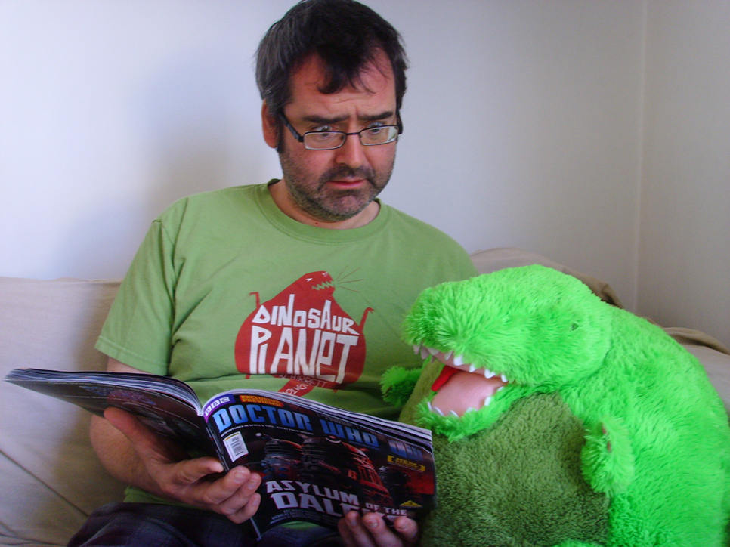
MJ Hibbett and one of the stars of the 'Dinosaur Planet' musical
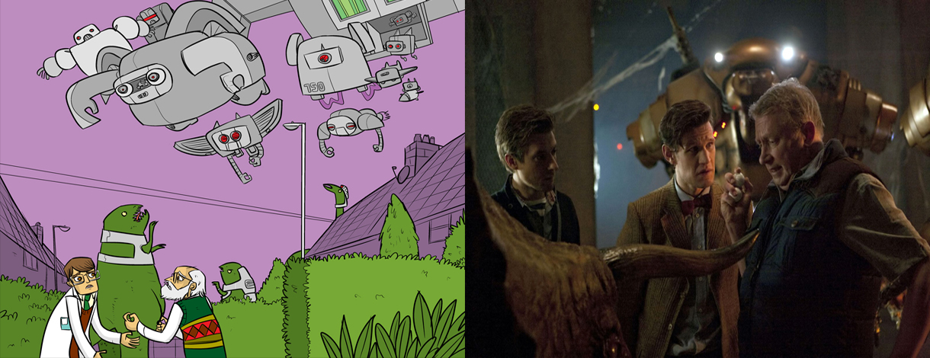
Comparison of images from 'Dinosaur Planet' and Doctor Who
Links
'Dinosaur Planet' trailer (released July 2011): http://www.youtube.com/watch?v=Z8FmpYdKKsA
Doctor Who 'Dinosaurs On A Spaceship' trailer (released September 2012): http://www.bbc.co.uk/programmes/p00y2s0b
'Dinosaur Planet' website: http://www.dinosaurplanet.co.uk
Background
MJ Hibbett & The Validators have performed live on Radio One, had a Record Of The Year in Rolling Stone, an Album Of The Day on 6Music, toured all around the world and very narrowly avoided writing an autobiography. They're probably best known for 'Hey Hey 16K', the world's first ever internet viral hit.
'Dinosaur Planet' was released in February 2012 and has been called "Jeff Wayne's new competition" by SFX, "the space dinosaurs vs. giant robots rock opera you've been waiting for" by io9.com and "The Greatest Story (About Space-Faring Dinosaurs) Ever Told (In a Rock Opera)" by Comics Alliance.
Guest stars include Phil Wilson (The June Brides), Chris T-T, Keith Top Of The Pops, BBC One continuity announcer Claire Gibb and BBC Radio Tees DJ Bob Fischer.
All of the album illustrations were drawn by John Allison, creator of the long-running online comics Bad Machinery, Bobbins and Scarygoround.

