PRESS RELEASE | 12 November 2012

Battle For The Spirit Of 'War Of The Worlds'
MJ Hibbett & The Validators re-release sci-fi concept album 'Dinosaur Planet'
at half price to fight back against new version of Jeff Wayne's 'War Of The Worlds'

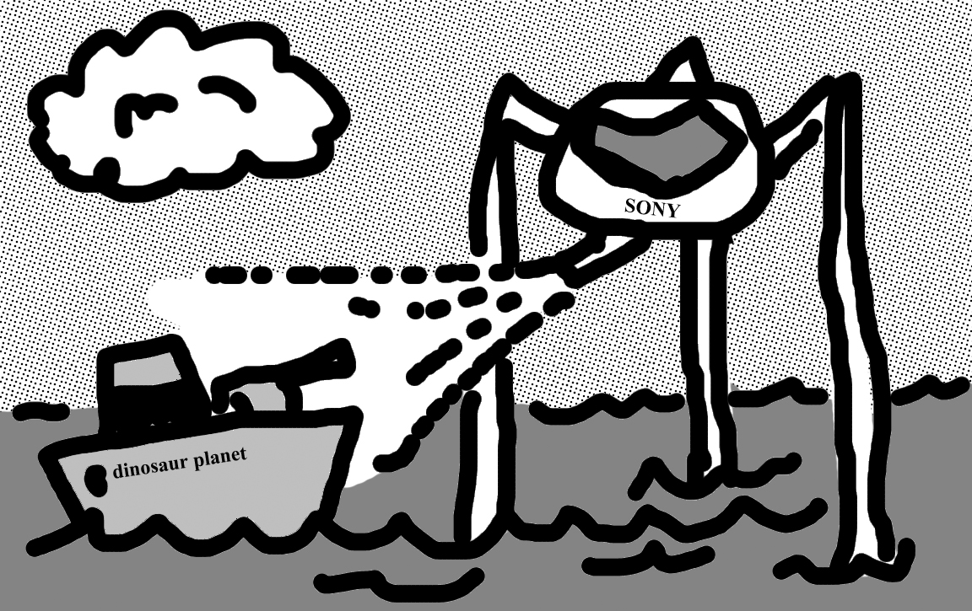
(artist's impression)

No one would have believed, in the early years of the twenty first century, that a concept album by MJ Hibbett & The Validators called 'Dinosaur Planet' would be hailed by some as the successor to Jeff Wayne's classic 'War Of The Worlds'.

No one could have dreamed that, across the gulf of the record industry, minds immeasurably wealthier than our own regarded this 'Dinosaur Planet' with envious eyes, and slowly and surely, they drew their plans against it.

On the twenty sixth of November a huge mass of luminous gas will erupt from Sony Records
and speed towards Earth. It's called 'Jeff Wayne's Musical Version Of The War Of The Worlds - The New Generation', starring Gary Barlow, Jess Stone, and That Bloke Out Of Kaiser Chiefs.

If mankind succumbs to this album MJ Hibbett & The Validators have a plan to start a new life for science fiction rock operas somewhere that Sony will never find them - underground. Lead singer MJ Hibbett says "We've taken a look around us, at the world we've come to know. It doesn't seem to be much more than a crazy circus show."

But maybe from this madness something beautiful will grow. In order to combat the invasion 'Dinosaur Planet' is being re-released on the band's own website at half price "Can't you just see it?" says MJ. "The album starting all over again - a second chance. We'll even offer t-shirts for half price too! Nothing can stop men like us."

Any other survivors wishing to join the band's brave new world can do so by visiting http://www.dinosaurplanet.co.uk where half-price albums and t-shirts will be for sale from 26 November until Christmas - or until the entire board of Sony Records catch a cold and keel over, whichever comes first.

Press release, images and videos at http://www.dinosaurplanet.co.uk/
For more information contact MJ Hibbett at mjhibbett@gmail.com

Background
MJ Hibbett & The Validators have performed live on Radio One, had a Record Of The Year in Rolling Stone, an Album Of The Day on 6Music, toured all around the world and very narrowly avoided writing an autobiography. They're probably best known for 'Hey Hey 16K', the world's first ever internet viral hit.
'Dinosaur Planet' was released in February 2012 and has been called 'Jeff Wayne's new competition' by SFX, 'the space dinosaurs vs. giant robots rock opera you've been waiting for' by io9.com and 'The Greatest Story (About Space-Faring Dinosaurs) Ever Told (In a Rock Opera)' by Comics Alliance.
Guest stars include Phil Wilson (The June Brides), Chris T-T, Keith Top Of The Pops, BBC One continuity announcer Claire Gibb and BBC Radio Tees DJ Bob Fischer.
All of the album illustrations were drawn by John Allison, creator of the long-running online comics Bad Machinery, Bobbins and Scarygoround.

